Please remove the Our Community link in the programs section beside Programs – it is the same as our mission statement, so we do not need it.

Under the programs description – please edit to say:

CV has nearly a 175-year history of caring for children and families. Our mission and impact are carried out through several focused strategies: prevention of child and family separation; temporary care and treatment for youth who cannot remain with family; support for youth development and transition; and our wide array of community investments that includes crisis response and model housing development.

Please use this link and replace photos as shown below: Stock Photos For Career Social Media - Google Photos

Change photo of Programs to 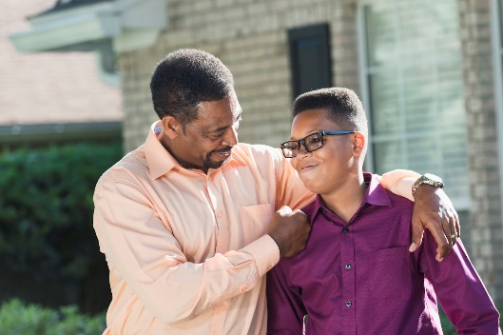

Change photo of Advocacy to 

Change photo of Fostercare to 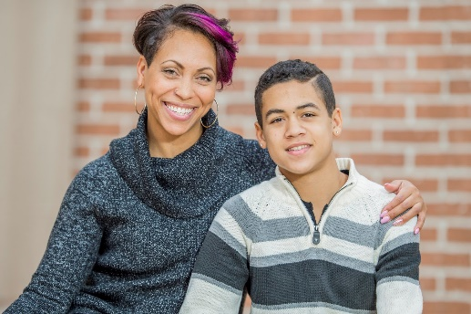

Annual Report 

Article 

Blog 

Who We Are 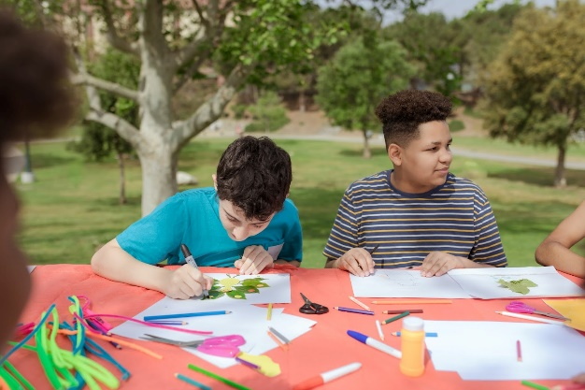

Under Who We Are
The Children’s Philosophy 

Get Involved 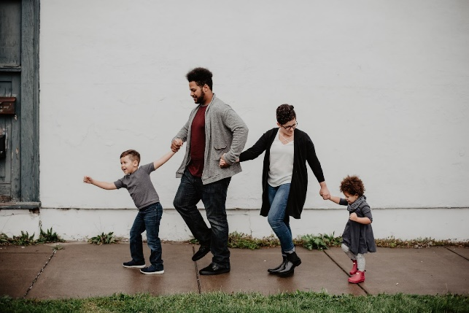

Our Stories 

Our Outcomes and Achievements 

Our Team 

Financials 

Advocacy

History 
Locations 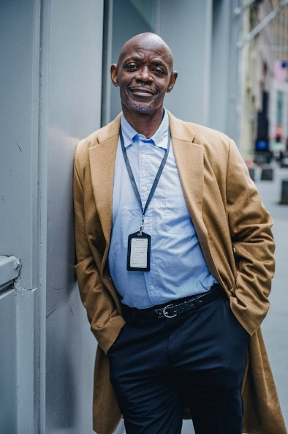

We need to add Undoing Institutional Racism under the What We Do
Content: Creating a culture of inclusion has been a core value at CV for some time. In 2010, CV’s Undoing Institutionalized Racism (UIR) committee was founded. The UIR committee has been a longstanding workgroup convened to examine and address inequities in CV’s internal systems, work with families and as advocates with external systems. The committee recognizes that race relations are important in institutionalized settings, and is charged with the responsibility of being honest and compassionate about how CV works with staff and families. It is the place where race, ethnic differences, color and boundaries are addressed head on.
In the years since its founding, the UIR committee has effected major change at CV. This has included leading workshops on disproportionality, developing bilingual positions, calling for transparency in promotion and hiring practices, providing workshops on trauma and racism, developing protocols for police involvement with our youth, and much more. In addition to examining internal policies and reviewing best practices, there has also been a focus on external advocacy. The UIR committee has educated youth about the stop and frisk policy, done much work around voting advocacy, dispersed information on immigration rights, and offered multiple Know Your Rights trainings.
We also need to add Integrated, Beautiful and Affordable Housing:
Content: The Eliza, The Harlem Building, the future CV/Urban Pathway partnership, and the Peekskill site are successful examples of our proof-of-concept mixed-use housing model that combine integrated, beautiful and affordable homes in the desirable neighborhoods. This housing offers resources that include access to nearby parks, transportation, restaurants and many other amenities.

Christopher Rucas
Director of Public Relations & Communications
Office: (914) 693-0600 ext: 4696
Cell: (914) 446-3863
One Echo Hills, Dobbs Ferry, NY 10522


